Ground Fault Detection and Insulation Monitoring
Norbert Doerry
October 15, 2026
- Introduction
Many shipboard power systems employ either ungrounded or high resistance grounded power distribution system; they can continue normal operation with a single ground fault. The amount of ground fault current depends on the power system’s line-to-ground capacitance from sources such as the cables and electromagnetic interference (EMI) filters. However, should a second ground fault on a different phase occur, the resulting line-to-line fault may lead to significant ground fault current at two different locations before circuit protection clears one or both faults. In the end, one or more critical loads may have lost power and their loss may put the ship at risk. Consequently, in ungrounded and high resistance grounded power distribution systems, the operator should be informed if a single ground fault exists, and the operator should have a procedure to quickly identify the source of the ground fault and make necessary repairs to eliminate the ground fault; ground faults should be fixed as soon as the ship is in an operational situation where it is safe to do so. Using Ground Fault Circuit Interrupters (GFCIs) (or related devices) to protect a few circuits on an ungrounded or high resistance grounded power system may result in false tripping due to a ground fault on a circuit without a GFCI.
Low impedance ground faults on solidly grounded systems may result in high fault currents that activate traditional fault protection. Coordination of circuit breakers opens the nearest “upstream” circuit breaker from the ground fault. However, in solidly grounded 120 V circuits, one of the two power conductors is typically grounded (and is often called a “neutral” although its voltage is not at the neutral voltage). If this grounded conductor has a ground fault, substantial current may flow through the hull to complete the circuit without activating traditional circuit protection. GFCIs (or related devices) may prove useful in this situation.
- Ground Fault Detection
  - Ungrounded systems
    - Ground detection lamps
Figure 1 depicts a simple ungrounded distribution system with three feeder cables powered from a power panel. The power panel has an input circuit breaker, one circuit breaker for each circuit, and a set of ground detection lamps. Phase A of circuit 3 has a ground fault. As indicated, the current through the fault is provided via the parasitic capacitances to ground of the unfaulted phases (phase B and C) of all three feeder cables. The protective earth conductor (equipment ground) may (or may not) be part of the conductive path between the ground connection of the parasitic capacitances and the location of the ground fault.
A ground fault may be detected using ground detection lamps as depicted in Figure 2. The three lamps are connected in wye, with the wye common point connected to ground via a normally closed switch as depicted in Figure 3. Without a ground fault, all three lamps are dimly lit (line-to-neutral voltage). With a ground fault, the faulted phase’s lamp will not be lit and the unfaulted phases’ lamps will be brightly lit (line-to-line voltage). The test switch is used to ensure that none of the lamps is burned out; depressing the switch disconnects the wye common point to ground resulting in all three lamps being dimly lit if none are burned out.
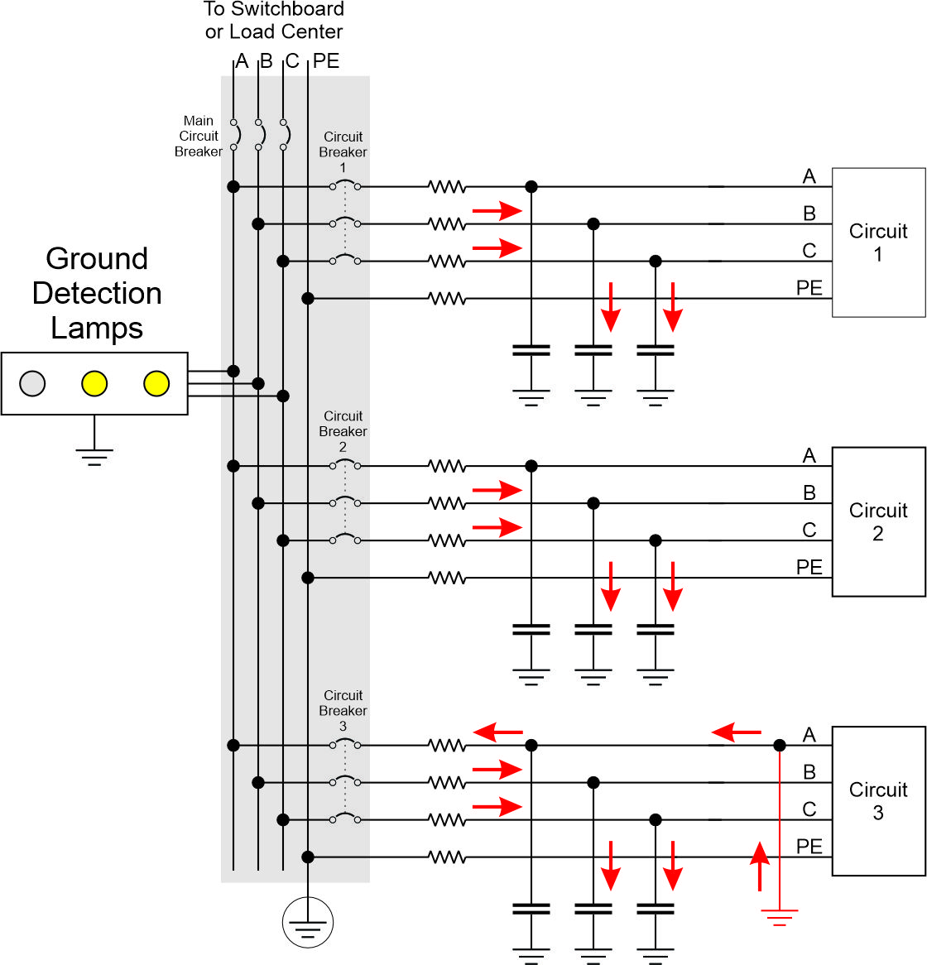
Figure 1: Ground fault in ungrounded power distribution system
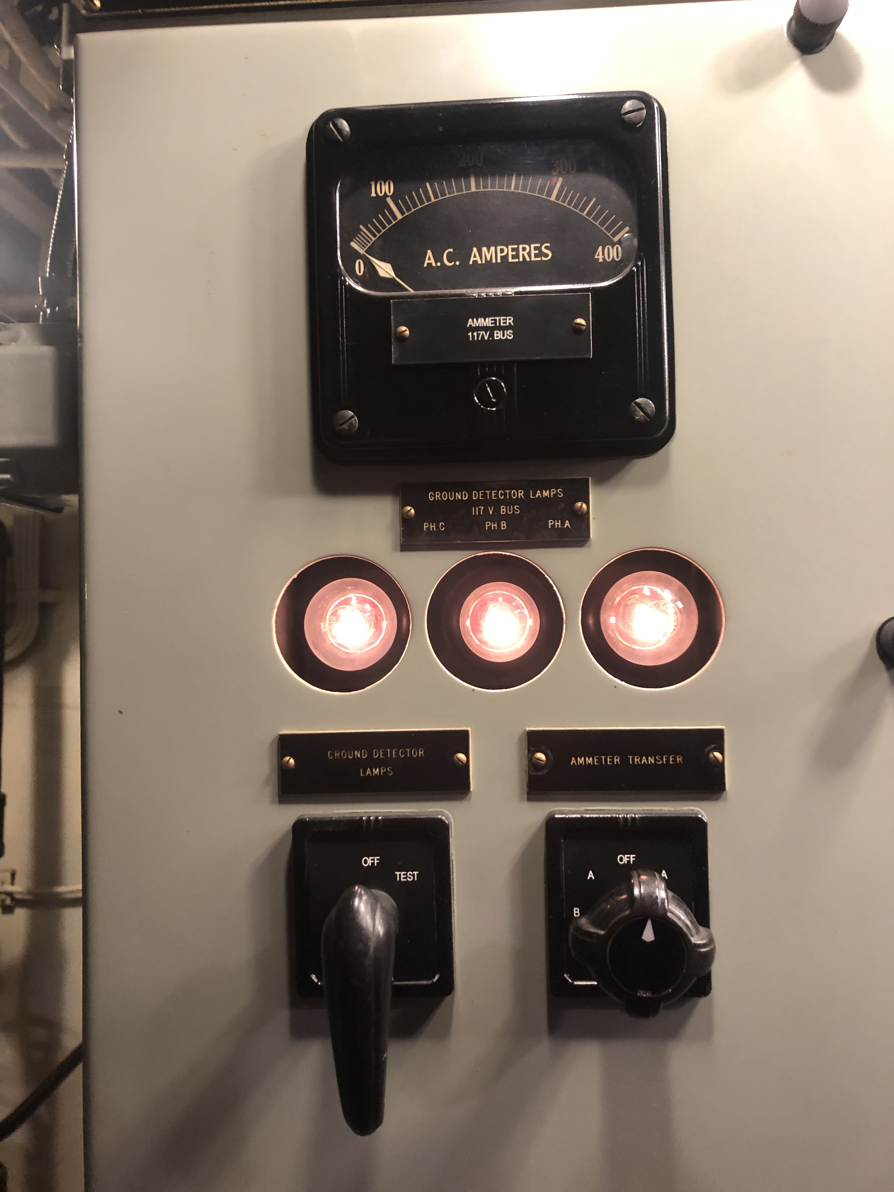
Figure 2: USS Slater (DE-766) Ground Detection Lamps (Photo by Norbert Doerry: CC BY 4.0)
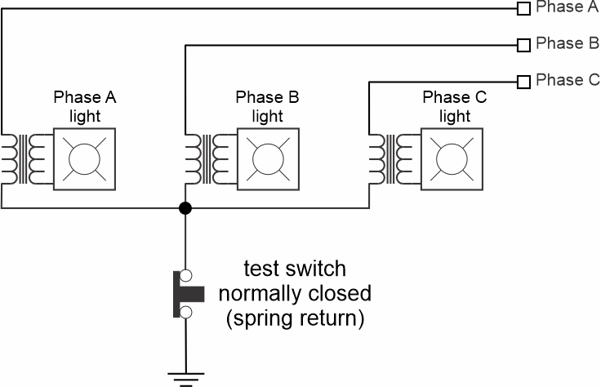
Figure 3: Ground detection lamp schematic
    - Insulation monitoring devices
Some ships employ insulation monitoring devices instead of ground detection lamps. Insulation monitoring devices estimate the resistance of the insulation for each phase; if the insulation resistance falls below a preset value, then the operator is notified. Insulation monitoring devices can identify failing insulation before an actual ground fault occurs.
Insulation monitoring systems and ground detection lamps are not compatible; the line to ground impedance of the lamps is likely low enough for the insulation monitoring system to interpret the impedance as failing insulation.
    - Line to ground voltage measurements
It is also possible to detect line-to-ground faults by individually measuring the three line-to-ground voltages. If the calculated neutral voltage of the three phases differs significantly from ground, then insulation degradation or a ground fault of a single phase may be presumed. If the impedance of the voltage sensor measure is not high enough, an insulation monitoring device may interpret the impedance of the voltage sensor as failing insulation.
    - GFCI
The common mode (CM) current of a set of conductors is the sum of the currents through the conductors. Normally, in a power cable one would expect this sum to equal zero; to complete a circuit, the amount of current entering a load should equal the amount of current leaving the load. If a common mode current exists, then a current equal to the common mode current is flowing external to the power cable from the load to the source; usually, but not always, this common mode current flows through ground (The ship’s hull and structure). A GFCI measures the common mode current and will trip if greater than about 5 mA. Residual Current Detectors (RCD) are similar devices that only detect common mode currents greater than about 10 mA. A combination of an RCD and miniature circuit breaker is designated an RCBO. GFCIs are typically employed in the United States; RCDs and RCBOs are typically used in the European Union. These devices are used mainly to protect personnel. Another device that operates in a similar manner is the Applicance Leakage Current Interrupter (ALCI) that trips with a common mode current of about 30 mA. For this paper the term GFCI is used to collectively represent all of these devices.
GFCIs may be able to detect and react to ground faults on their protected circuit as depicted in Figure 4(a). A ground fault on the circuit for Load 3 should correctly result in the GFCI tripping if there is sufficient line-to-ground capacitance on all the circuits. If there is not sufficient line-to-ground capacitance across all the feeder cables (and attached EMI filters), then the amount of available ground fault current and the resulting common mode current may not be sufficient to trip the GFCI. If ground detection lamps are installed on the circuit, they may provide sufficient ground fault current to trip the GFCI.
As depicted in Figure 4(b), if the line to ground capacitance of the GFCI’s protected circuit (Load 3) is high enough (such as through the presence of an EMI filter), a ground fault on a different circuit (Load 2) may cause sufficient current through the unfaulted phase of the GFCI protected circuit to cause the GFCI to sense a high enough common mode current to incorrectly trip; this would be considered a nuisance trip and is very undesirable. When employing GFCIs on ungrounded circuits, one should ensure that the line-to-ground capacitance on the protected circuit is minimized and below the threshold of that required to trip the GFCI.
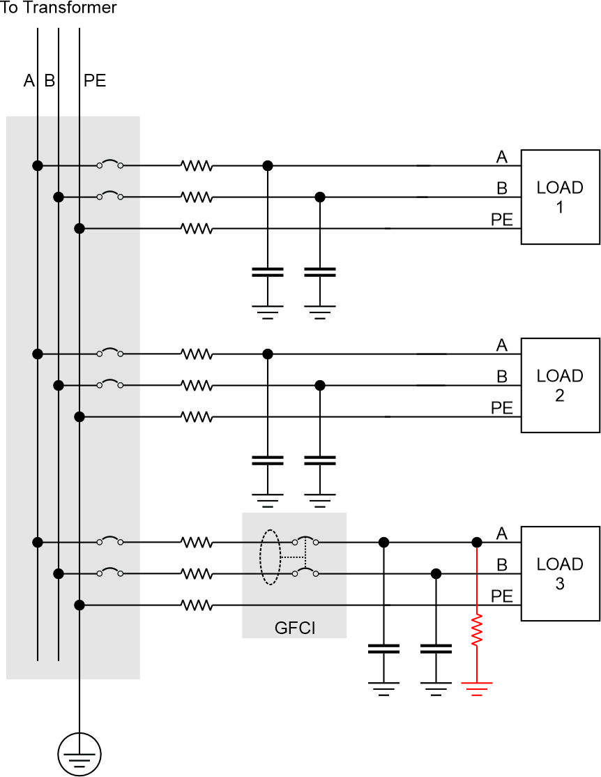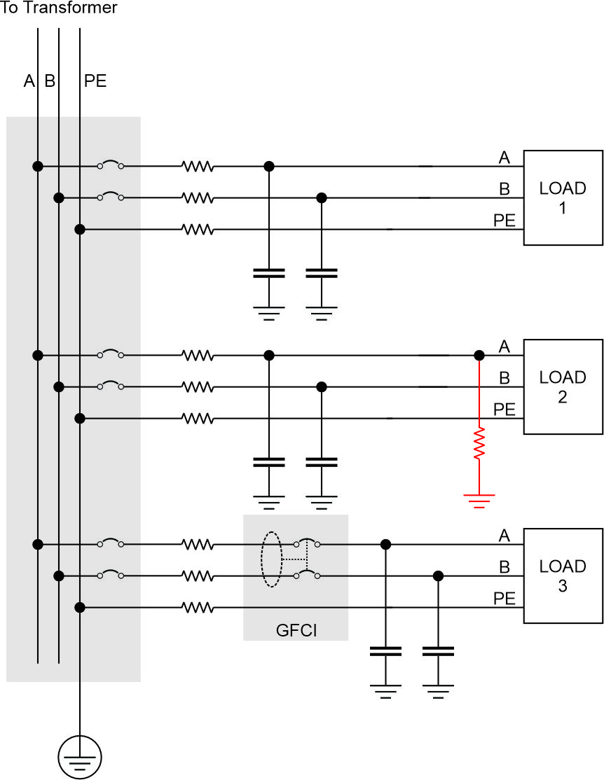
(a) (b)
Figure 4: GFCI protected circuit on ungrounded system; Ground fault on (a) protected circuit (b) unprotected circuit
  - High resistance grounded systems
    - Ground detection lamps
As depicted in Figure 5, ground detection lamps work in the same way as for ungrounded systems. The grounding resistor provides an additional path for the ground fault current to flow through. Note that when the ground detection lamps are connected to ground (the test button is not depressed), the ground detection lamps act as grounding resistors, but likely are not of the correct resistance to effectively mitigate voltage transients.
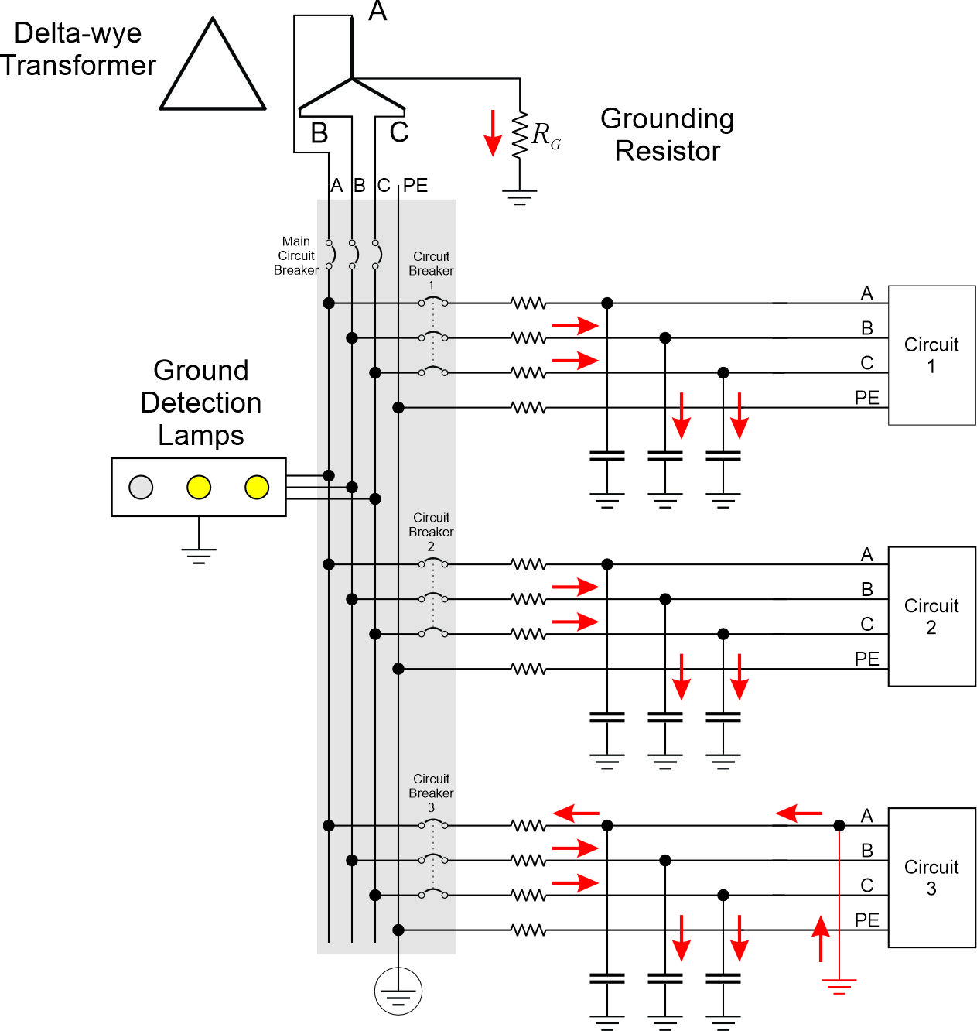
Figure 5: Ground fault in high resistance grounded power distribution system
    - Voltage and current measurements on grounding resistor
Voltage and current sensors are typically installed on the grounding resistor. Under unfaulted conditions, the voltage across the grounding resistor should be near zero as well as the current through the grounding resistor. Any substantial voltage across or current through the grounding resistor is an indication of a ground fault. By measuring both the voltage and current, a control system can determine whether a grounding resistor or its connections have failed. In medium voltage applications, a transformer may be employed to reduce the voltage to a low voltage so that lower cost sensors may be employed.
    - Line-to-ground voltage measurements
As with ungrounded systems, detecting line-to-ground fault by individually measuring the three line-to-ground voltages is possible. If the calculated neutral voltage of the three phases differs significantly from ground, then insulation degradation or failure of a single phase may be presumed. Since insulation monitoring devices are not compatible with high resistance grounded systems (the insulation monitoring system will also measure the grounding resistor), the impedance of the voltage sensor is not as significant as compared to ungrounded systems.
    - GFCI
GFCIs perform about the same in high-resistance grounded systems as compared to ungrounded systems. The grounding resistor does provide additional ground fault current, so it is more likely that there will be sufficient ground fault current on a faulted circuit to trip the GFCI; the grounding resistor value can be adjusted to ensure this happens. Keeping the line-to-ground capacitance low on a GFCI protected circuit is still important to avoid tripping the GFCI when a ground fault occurs on a different circuit.
  - Solidly grounded systems
    - Coordinated circuit breakers
Figure 6 depicts a solidly grounded power system with a ground fault on phase A. While the currents through the parasitic capacitances of the unfaulted phases contribute to the fault current, these currents are dwarfed by the fault current through the ground connection and the faulted phase. The fault current is only limited by the low impedances of the source, cables, ground fault, and ground and can be well in excess of 1000 amps. The time-current profiles of the circuit breakers between the fault and the source of power (usually either a generator or a transformer) are selected such that the closest circuit breaker upstream of the fault trips. In this way, the fault is removed while de-energizing the fewest number of loads.
In solidly grounded systems, many ground faults are removed as quickly as they are detected. This property may not be desirable if critical loads are de-energized; it may be preferential to operate for a short period of time with a ground fault. For circuits that feed only non-critical loads, removing ground faults as quickly as possible enhances safety.
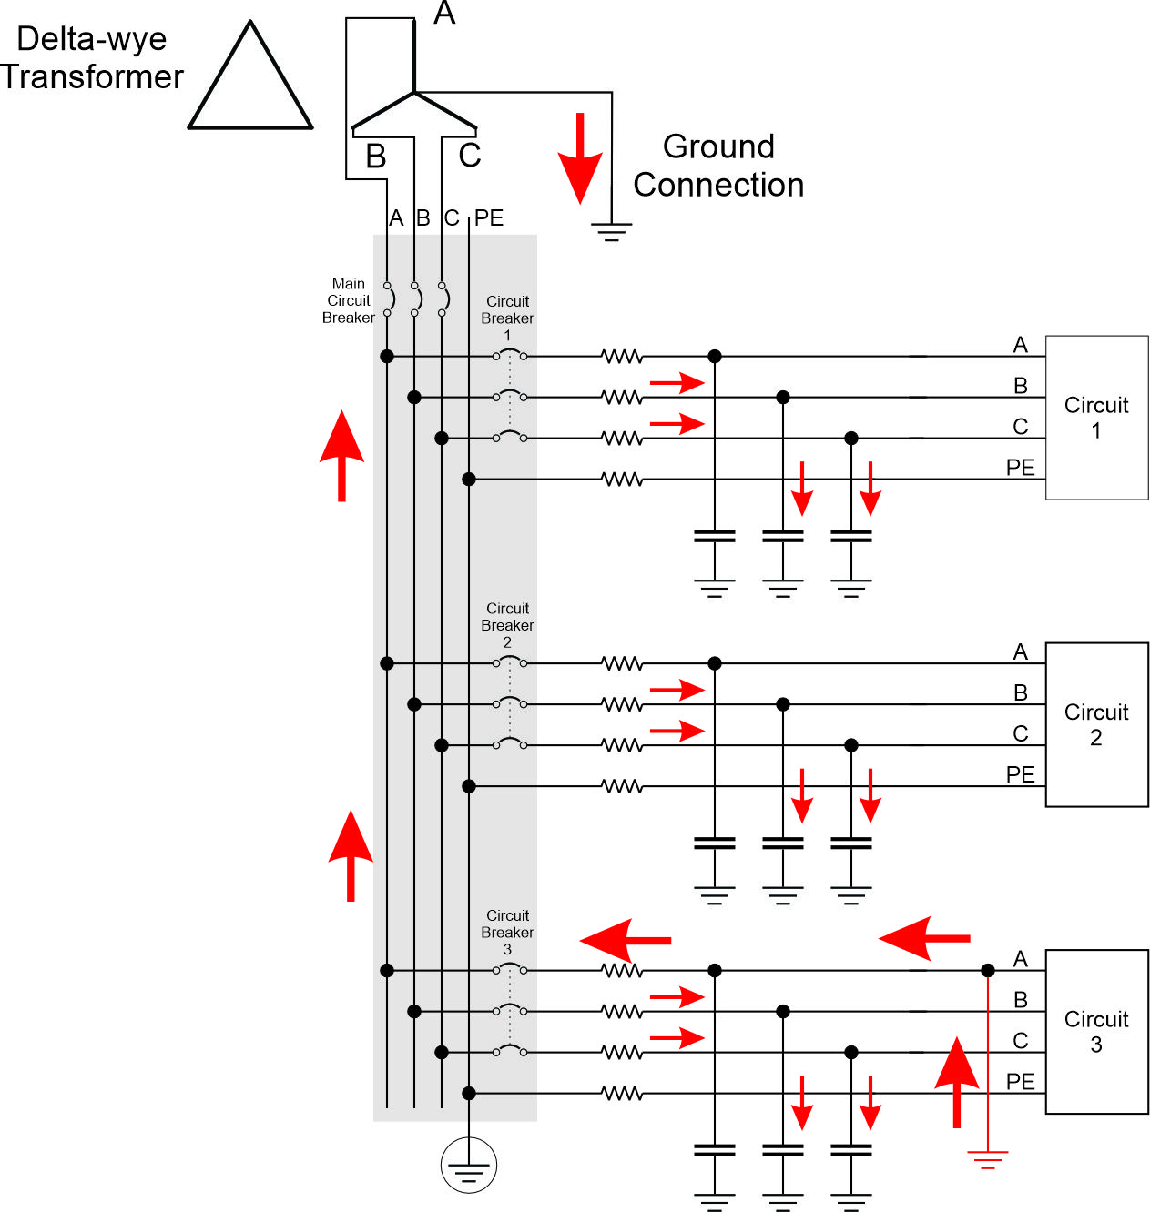
Figure 6: Ground fault in solidly grounded power distribution system
    - Current meter on ground connection
If the ground fault is of high enough impedance, the ground fault current may not be sufficient to trip any of the circuit breakers. A current meter on the ground connection does enable one to determine if a ground fault exists within the power system, but will not indicate where that ground fault is located.
    - GFCI
Figure 7 depicts the application of a GFCI in a solidly grounded system where one of the conductors is solidly grounded (N) while the voltage to ground on the other conductor (L) is roughly equal to the nominal system voltage. In Figure 7(a) the ground fault is on the L conductor. If the impedance to ground is very small, the normal circuit breaker should trip. If the impedance of the ground fault is such that the fault current is too small for the normal circuit breaker to trip, but large enough for the GFCI to trip, then the GFCI will trip. In Figure 7(b) the ground fault is on the N conductor. In this case the ground fault current is a portion of the normal load current; the exact amount depends on the relative magnitude of the cable impedance and the ground fault / ground impedance. Since the normal load current should be less than the circuit breaker trip rating, the circuit breaker should not trip. The GFCI will trip if the ground fault current exceeds the GFCI trip setting. in order for the GFCI to trip, a ground fault on the N conductor requires a much smaller impedance as compared to the ground fault impedance for a ground fault on the L conductor.
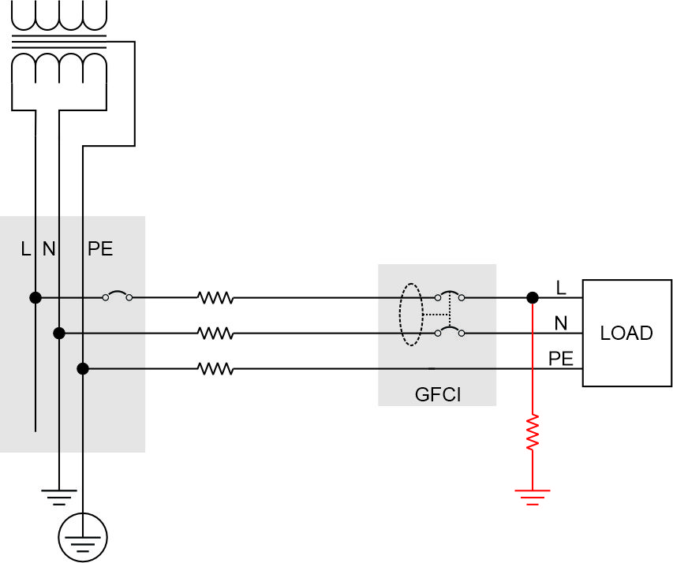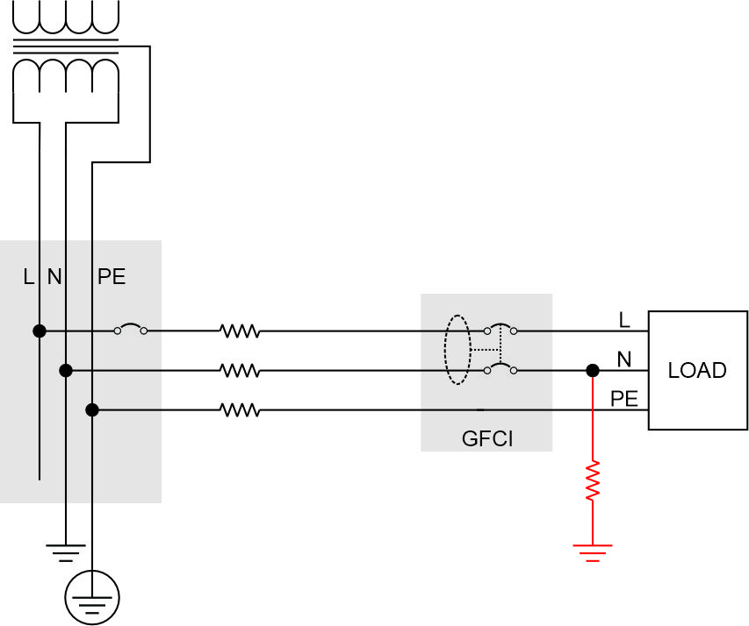
- (b)
Figure 7: GFCI in solidly grounded power distribution system; Ground fault on (a) line conductor (b) grounded conductor
- Ground fault localization and isolation
  - Introduction
Once a ground fault has been detected, the location of the ground fault should be determined so that the faulted equipment can be electrically isolated and then repaired. In some cases, the ground fault is only localized to a specific circuit downstream of a circuit breaker; the electrician must physically inspect the cable and equipment downstream of the circuit breaker to find the ground fault. In other cases, portable test equipment may be employed to localize the ground fault to a specific section of cable, or to a specific piece of electrical equipment.
  - Ungrounded system
    - “Stripping the board”
In an ungrounded system with ground detection lamps, the traditional approach to localizing a ground fault to a particular circuit is to start with the switchboard, load center, or power panel connected to a power source (Figure 8). Each circuit breaker (or fuse) powering a circuit is turned off in sequence. If the ground fault indication on the ground detection lamps disappears when a circuit is turned off, then that circuit is likely the faulted circuit. If not, the circuit breaker is turned back on and the next circuit breaker is turned off. If the faulted circuit has not been found after all the circuits have been checked, then the ground fault is within the switchboard, load center, power panel, within the cable to the transformer or generator, within the transformer or generator, or there are multiple circuits with ground faults on the same phase. To eliminate this last case, all of the circuit breakers are shut off. If the ground fault persists, then the ground fault is not downstream of the circuit breakers; physical inspection is needed to find the fault upstream of the circuit breakers. If the ground fault is not present when all the circuit breakers are shut off, then multiple circuits likely have ground faults on the same phase. With all the circuit breakers initially off, each circuit breaker is turned on. If the ground fault appears, the last circuit breaker to been turned on has a ground fault. The circuit breaker for the faulted phase is turned off and the next circuit breaker is turned on until all the circuits with ground faults are identified.
Physical examination of the cable and equipment associated with the faulted circuit is often employed to identify the source of the ground fault. Alternately, the location of the fault along the faulted circuits cable may be identified using the common mode current measurement technique described in section 3.2.2.
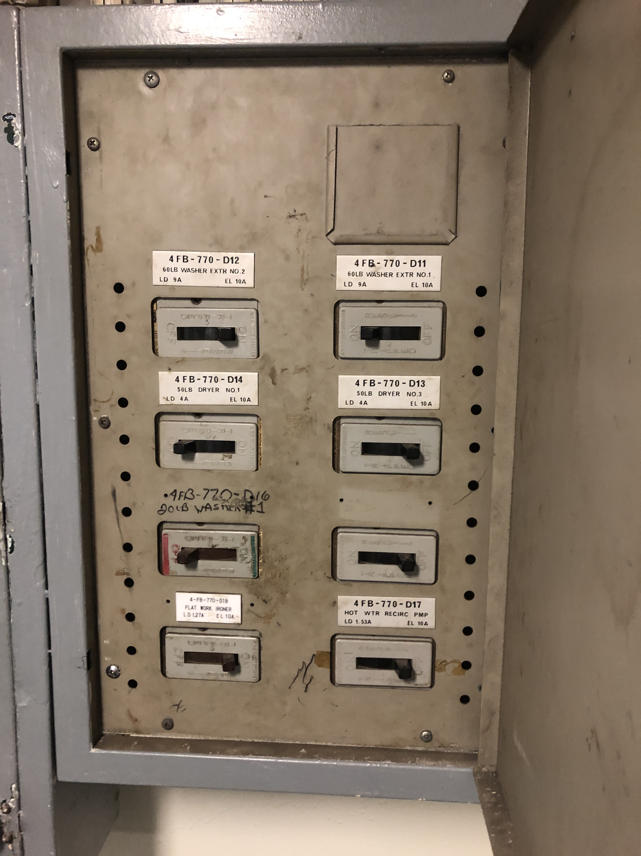
Figure 8: USS Midway (CV-41) Power Panel (Photo by Norbert Doerry CC BY 4.0)
One of the down-sides of this method is that power is shut off, at least for a short time, on most, if not all, of the circuits. This can be very disruptive to shipboard operations. Shipboard operations often limit when ground fault localization efforts may be conducted. Delaying ground fault localization increases the probability of a second ground fault occurring; multiple ground faults either result in a line-to-line ground fault that is cleared immediately (perhaps to the detriment of shipboard operations) or results in greater difficulty in finding multiple ground faults on the same phase.
    - Common mode (CM) current measurement
The common mode current through an unshielded three phase cable may be measured with a clamp on current meter as depicted in Figure 9. The current meter is clamped around all the power conductors of a cable and it measures the sum of the current enclosed by the clamp probes (common mode current). As shown in Figure 1, all of the circuits within a power system with a ground fault will likely have a common mode current. The circuit with the largest magnitude common mode current is likely the one with a ground fault. This can be confirmed by switching off the circuit breaker for this one circuit and verifying that the ground detection lamps no longer indicate a ground fault.
Once a circuit with a ground fault has been found, the location may be determined by observing the magnitude of the common mode current along the path of the circuit’s cable; the common mode current is likely to have a step decrease at the location of the ground fault.
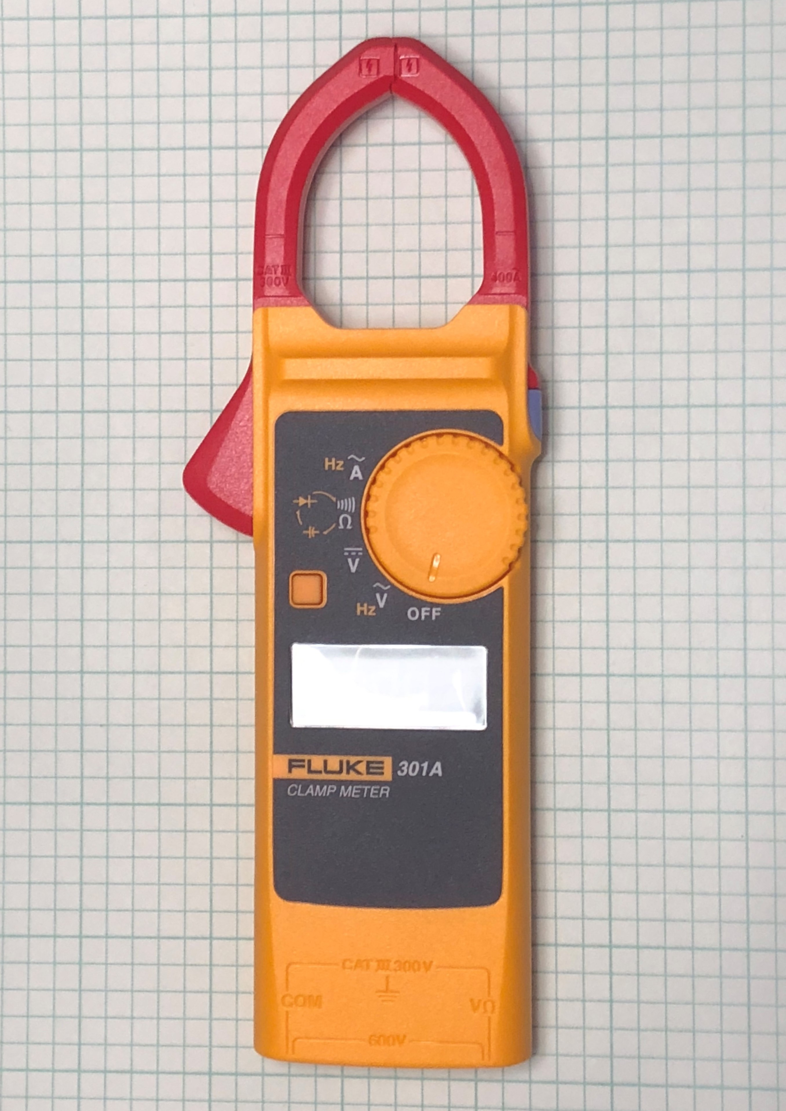
Figure 9: Fluke 301A Clamp Meter (Photo by Norbert Doerry CC BY 4.0)
    - Low resistance grounding of neutral
As depicted in Figure 10, another technique for localizing and isolating the ground fault is to temporarily insert a low resistance grounding resistor between the neutral of the power system (perhaps using a grounding transformer) and ground. The resulting fault current should be limited to prevent equipment damage, but large enough for the normal coordinated circuit breakers to selectively trip and isolate the circuits with ground faults. Activating this low resistance grounding resistor can be scheduled so as to not interfere with ship operations.
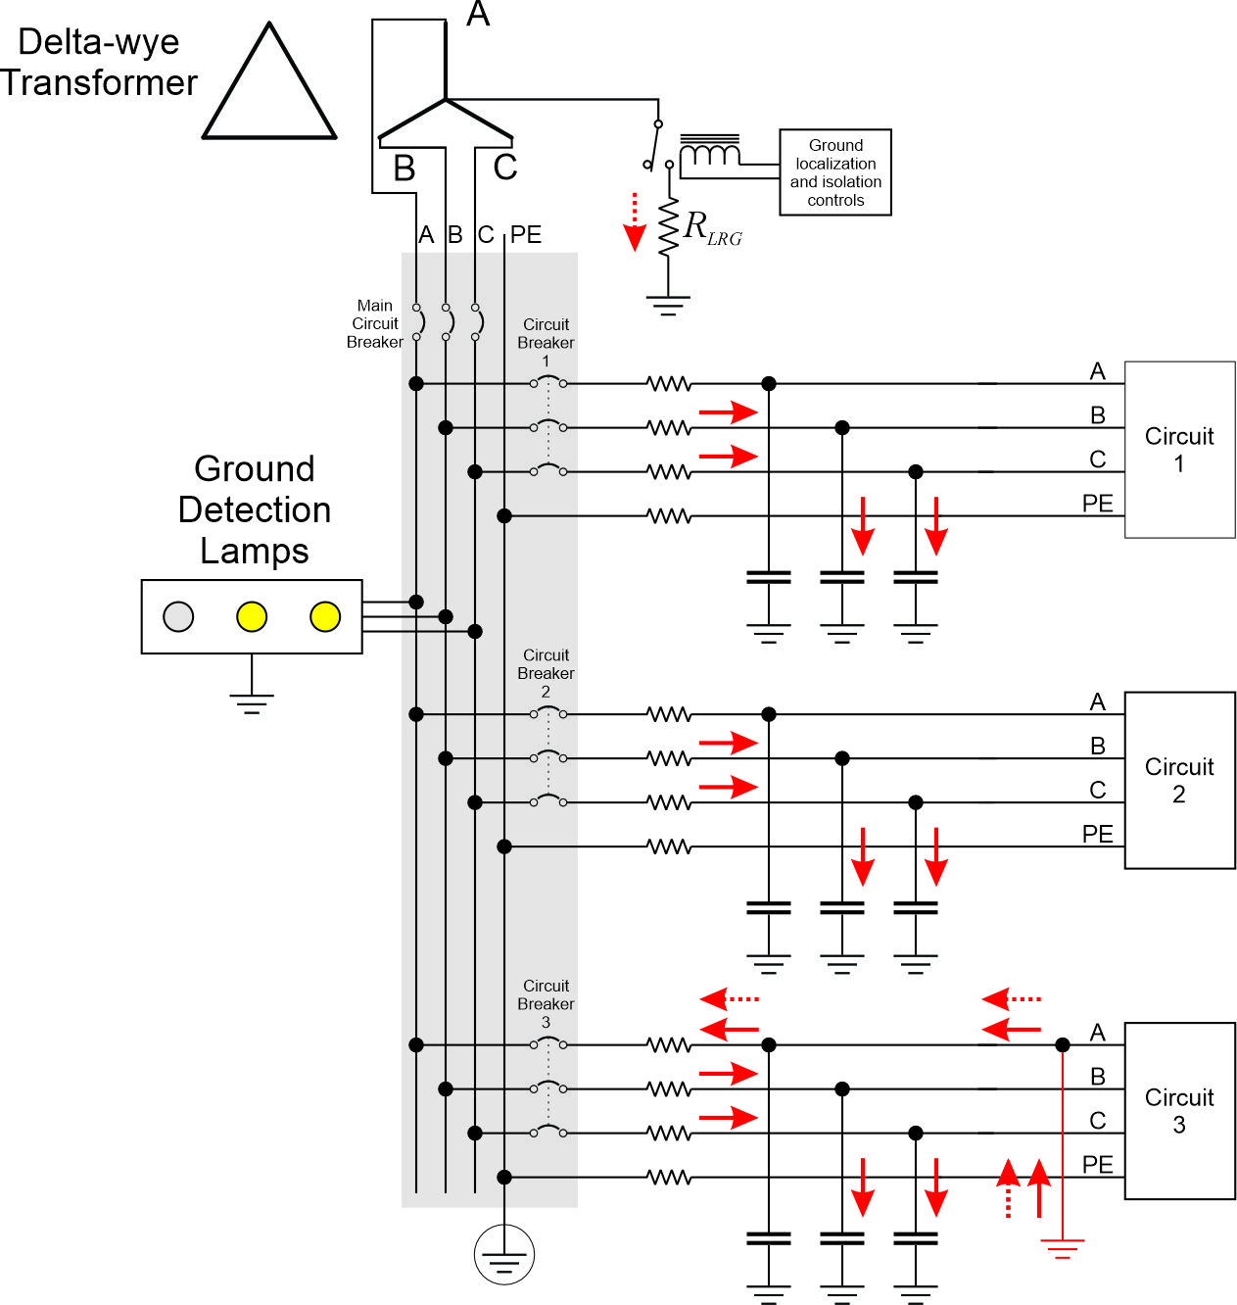
Figure 10: Ungrounded Power System use of low resistance grounding resistor to localize and isolate ground fault
    - GFCI
By tripping, GFCIs inherently isolate a ground fault. The location of the ground fault is usually accomplished through physical inspection of the cable and equipment of the portion of the circuit isolated by the GFCI.
  - High resistance grounded system
    - Common mode current measurement
The common mode current measurement method described in section 3.2.2 works even better in a high resistance grounded system. The common mode current in the circuit with the ground fault will include the current through the grounding resistor. Furthermore, the phase relationship of the common mode current to the common mode voltage will be 90 electrical degrees for the unfaulted circuits and much less for the faulted phase (since it has a large resistive component from the grounding resistor).
    - Pulsed resistance
If a second resistor is periodically (typically about 1 Hz) connected in parallel to the grounding resistor as shown in Figure 11, then the common mode current in the faulted circuit will reflect the pulsing current through the two resistors while the common mode current in the unfaulted circuits will remain relatively constant.
Once a circuit with a ground fault has been found, the location may be determined by observing the magnitude of the common mode current along the path of the circuit’s cable; the pulsing common mode current will largely disappear at the location of the ground fault.
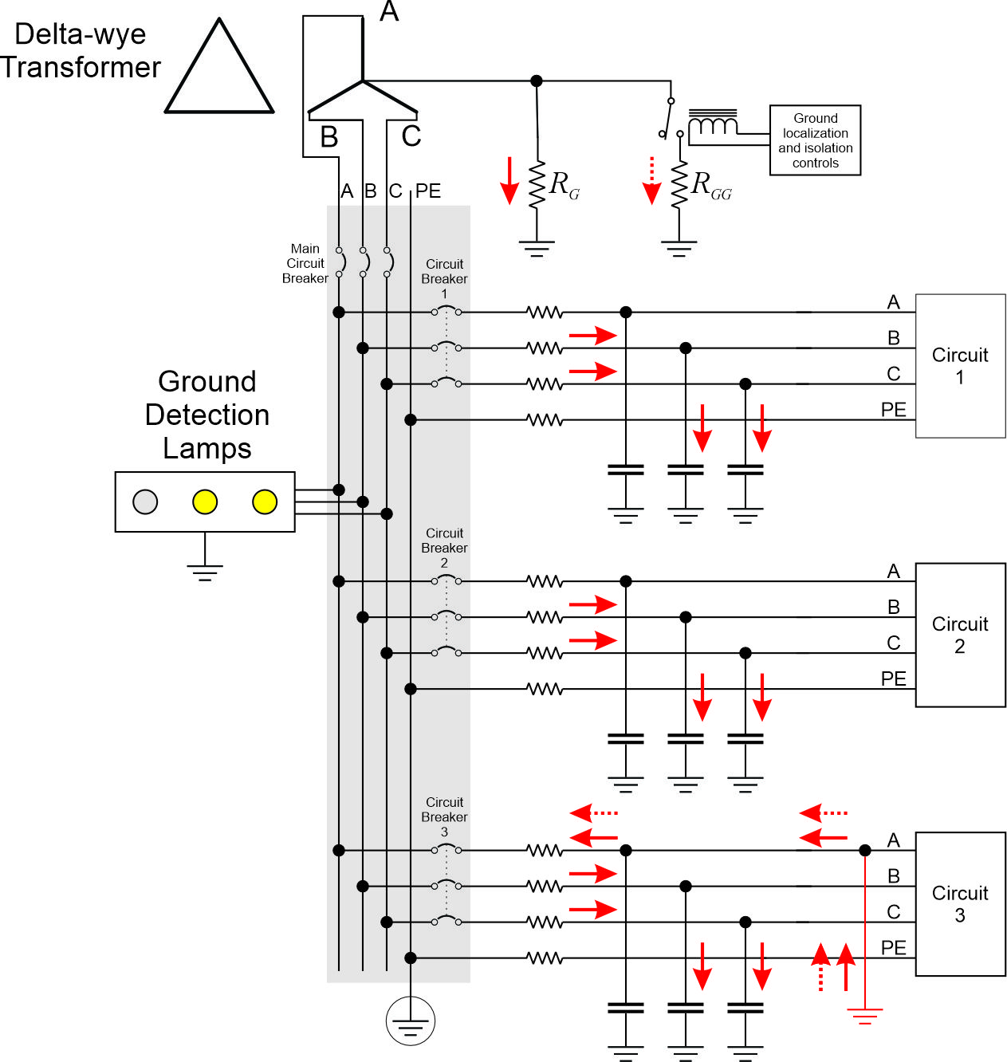
Figure 11: High Resistance Power System use of pulsing grounding resistor to localize ground fault
If the second resistor has a sufficiently low resistance, the ground fault current can be large enough for the coordinated circuit breakers to automatically clear the ground fault.
    - Injected signal
If a high frequency current signal is injected at the grounding resistor as depicted in Figure 12, then a portable wireless receiver can trace the path of this signal to the location of the ground fault.
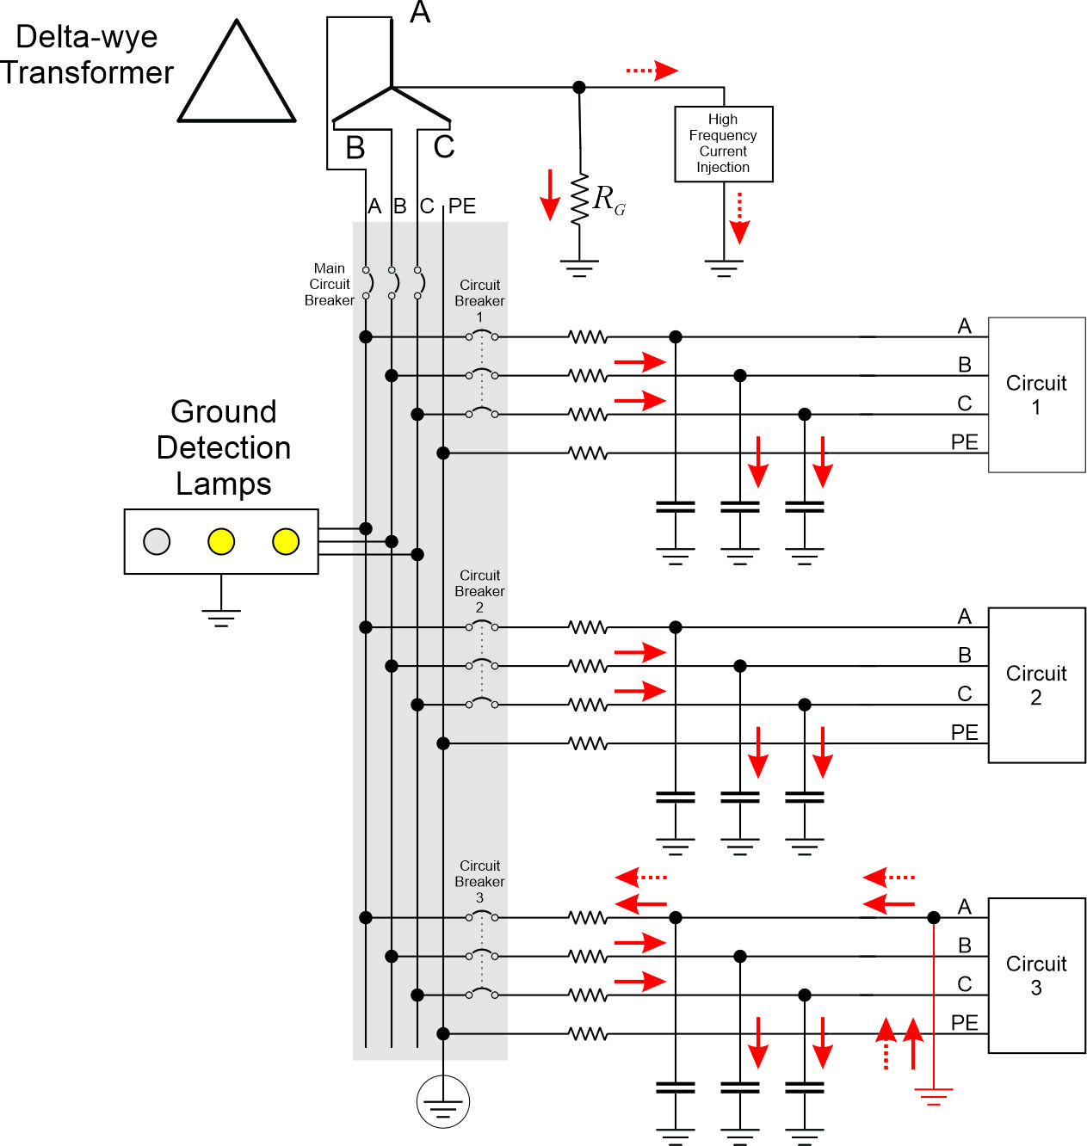
Figure 12: High Resistance Power System use of injected current to localize ground fault
    - GFCI
By tripping, GFCIs inherently isolate a ground fault. The location of the ground fault is usually accomplished through physical inspection of the cable and equipment of the portion of the circuit isolated by the GFCI.
  - Solidly grounded system
    - Coordinated circuit breakers
By tripping, circuit breakers inherently isolate both line-to-line faults and ground faults. The location of the fault is usually accomplished through physical inspection of the cable and equipment of the portion of the circuit isolated by the circuit breaker.
Coordinated circuit breakers result in the circuit breaker upstream and the closest to the fault tripping; the number of impacted loads is thereby minimized.
    - GFCI
By tripping, GFCIs inherently isolate a ground fault. The location of the ground fault is usually accomplished through physical inspection of the cable and equipment of the portion of the circuit isolated by the GFCI.
- References
IEEE Std 45.1 IEEE Recommended Practice for Electrical Installations on Shipboard--Design
IEEE Std 45.3 IEEE Recommended Practice for Electrical Installations on Shipboard--Systems Engineering
IEEE Std 3003.1 IEEE Recommended Practice for System Grounding of Industrial and Commercial Power Systems
Doerry, Norbert, Mohammed M. Islam, John Prousalidis, Design of Shipboard Power System Grounding / Earthing , IEEE Press - Wiley, January 2025, ISBN-10 1119933080 ISBN-13 978-1119933083

